###### A PROJECT REPORT

###### ON

WINE QUALITY PREDICTION SYSTEM

Submitted by

**LAKSHYA DOGRA (RA2211026030023) PRAKHAR AGARWAL (RA2211026030014)**

**PARTH SINGH (RA2211026030016)**

**NAVNNET KUMAR (RA2211026030013)**

Under the guidance of

##### Ms. Deepinder Kaur

*(Assistant Professor, Department of Computer Science & Engineering) in the partial fulfillment for the award of the degree of*

**BACHELOR OF TECHNOLOGY**

in

**COMPUTER SCIENCE & ENGINEERING**

of

**FACULTY OF ENGINEERING & TECHNOLOGY**



SRM INSTITUTE OF SCIENCE AND TECHNOLOGY DELHINCR CAMPUS, MODINAGAR SIKRI KALAN, DELHI MEERUT ROAD, DIST. - GHAZIABAD - 201204

APRIL, 2024

EVEN SEMESTER (2023-2024)

## SRM INSTITUTE OF SCIENCE AND TECHNOLOGY

**(Under Section 3 of UGC Act, 1956)**

**BONAFIDE CERTIFICATE**

v

It is to be certified that the project report "**WINE QUALITY PREDICTION SYSTEM**" the bonafide work of LAKSHYA DOGRA [RA2211026030023], PRAKHAR AGARWAL [RA2211026030014], NAVNEET KUMAR [RA2211026030013], PARTH SINGH [RA2211026030016] for Bachelor of Technology degree in the Department of Computer Science and Engineering, Delhi- NCR Campus, SRM IST has carried out the project work under my supervision.

###### SIGNATURE. SIGNATURE

**Ms. Deepinder Kaur Dr. Avneesh Vashishta**

**Assistant Professor Head of the Department**

**Department of Computer Science and Engineering Department of Computer**

**Science and Engineering**

## SRM INSTITUTE OF SCIENCE AND TECHNOLOGY

**(Under Section 3 of UGC Act, 1956)**

**BONAFIDE CERTIFICATE**

Certified that this minor project report for the course 21CSC305P MACHINE LEARNING entitled in WINE QUALITY PREDICTION SYTEM (ML PROJECT) is the

bonafide work of **LAKSHYA DOGRA (RA22110026030023)**

#### who carried out the work under my supervision.

###### SIGNATURE

**FACULTY OF ENGINEERING AND TECHNOLOGY SRM INSTITUTE OF SCIENCE AND TECHNOLOGY**

**DELHI NCR CAMPUS, MODINAGAR SIKRI KALAN, DELHI MEERUTROAD, DIST. - GHAZIABAD - 201204**

**DEPARTMENT OF COMPUTER SCIENCE AND ENGINEERING**

## SRM INSTITUTE OF SCIENCE AND TECHNOLOGY

**(Under Section 3 of UGC Act, 1956)**

**BONAFIDE CERTIFICATE**

Certified that this minor project report for the course 21CSC305P MACHINE LEARNING entitled in WINE QUALITY PREDICTION SYTEM (ML PROJECT) is the

bonafide work of **PRAKHAR AGGARWAL (RA22110026030014)**

#### who carried out the work under my supervision.

###### SIGNATURE

**FACULTY OF ENGINEERING AND TECHNOLOGY SRM INSTITUTE OF SCIENCE AND TECHNOLOGY**

**DELHINCR CAMPUS, MODINAGAR SIKRI KALAN, DELHI MEERUT ROAD, DIST. - GHAZIABAD - 201204**

**DEPARTMENT OF COMPUTER SCIENCE AND ENGINEERING**

## SRM INSTITUTE OF SCIENCE AND TECHNOLOGY

**(Under Section 3 of UGC Act, 1956)**

**BONAFIDE CERTIFICATE**

Certified that this minor project report for the course 21CSC305P MACHINE LEARNING entitled in WINE QUALITY PREDICTION SYTEM (ML PROJECT) is the

bonafide work of **NAVNEET KUMAR (RA22110026030013)**

#### who carried out the work under my supervision.

###### SIGNATURE

**FACULTY OF ENGINEERING AND TECHNOLOGY SRM INSTITUTE OF SCIENCE AND TECHNOLOGY**

**DELHINCR CAMPUS, MODINAGAR SIKRI KALAN, DELHI MEERUT ROAD, DIST. - GHAZIABAD - 201204**

**DEPARTMENT OF COMPUTER SCIENCE AND ENGINEERING**

## SRM INSTITUTE OF SCIENCE AND TECHNOLOGY

**(Under Section 3 of UGC Act, 1956)**

**BONAFIDE CERTIFICATE**

Certified that this minor project report for the course 21CSC305P MACHINE LEARNING entitled in WINE QUALITY PREDICTION SYTEM (ML PROJECT) is the

bonafide work of **PARTH SINGH (RA22110026030016)**

#### who carried out the work under my supervision.

###### SIGNATURE

**FACULTY OF ENGINEERING AND TECHNOLOGY SRM INSTITUTE OF SCIENCE AND TECHNOLOGY**

**DELHINCR CAMPUS, MODINAGAR SIKRI KALAN, DELHI MEERUT ROAD, DIST. - GHAZIABAD - 201204**

**DEPARTMENT OF COMPUTER SCIENCE AND ENGINEERING**

# ABSTRACT

### WINE QUALITY PREDICTION SYSTEM

The "Wine Quality Prediction System" is a machine learning-based application designed to predict the quality of wine based on various chemical properties. This project leverages Python's data science libraries and incorporates key machine learning techniques to build predictive models. Users can input wine characteristics such as acidity, sugar levels, and alcohol content, and the system will generate a quality score based on these features. With data preprocessing, feature engineering, and model training, the application ensures accurate predictions. The system also provides visualizations for better insights into the relationships between different wine attributes and quality scores. It serves as a powerful tool for winemakers, researchers, and enthusiasts aiming to evaluate and improve wine quality efficiently.

# ACKNOWLEDGEMENT

We would like to express our sincere gratitude and appreciation to Ms. Deepinder Kaur for his tremendous support and assistance in the completion of this project. We are deeply thankful to his for giving us the opportunity to be the part of this project. We wish to convey a sincere thanks to our dedicated team members whose efforts and collaborative spirit played a vital role in translating our vision into a reality. We also wish to acknowledge the support and encouragement received from friends and family who directly and indirectly contributed to the successful completion of our project.

# TABLE OF CONTENTS

|  |  |  |
| --- | --- | --- |
| **S. NO** | **CONTENTS** | |
| **1** | **INTRODUCTION** | |
|  | 1.1 | Motivation |
|  | 1.2 | Objective |
|  | 1.3 | Problem Statement |
|  | 1.4 | Challenges |
| **2** | **EXISTING PROBLEM** | |
| **3** | **PROPOSED SOLUTION** | |
|  | | |
| **4** | **TECHNOLOGIES USED** | |
|  | | |
| **5** | **ARCHITECTURAL DIAGRAM** | |
| **6**    7. | **METHODOLOGIES**  **RESULTS** | |
|  | | |
| **8** | **CONCLUSION** | |
| **9** | **REFERENCES** | |

**INTRODUCTION**

### WINE QUALITY PREDICTION SYSTEM (ML PROJECT):

##### Motivation:

##### The motivation behind the *Wine Quality Prediction System* is to assist winemakers, researchers, and enthusiasts in understanding and improving the quality of wine. By leveraging data-driven insights, this system enables users to make informed decisions about the wine production process, leading to better quality control and enhanced product development. Accurate quality prediction based on chemical properties offers significant value in optimizing wine production.

##### Objective:

##### I. Wine Quality Prediction

##### Efficient Data Input: Develop a system that allows users to input chemical properties of wine, such as acidity, sugar content, pH levels, and alcohol percentage, to predict quality scores.

##### Machine Learning Models: Integrate machine learning algorithms to analyze the relationship between wine attributes and quality, ensuring accurate and reliable predictions.

##### Real-time Feedback: Provide immediate predictions and feedback based on the entered data, helping users quickly assess wine quality.

##### II. Data Analysis and Visualization

##### Comprehensive Insights: Implement analytical tools to provide detailed insights into how different chemical features affect wine quality.

##### Visual Representation: Use graphs, charts, and other visual tools to display the relationships between wine attributes and quality, making the data easier to understand.

##### Predictive Modeling: Utilize predictive algorithms to forecast the quality of wine based on historical data, aiding in quality control and decision-making.

##### III. Reporting and Recommendations

##### Customized Reports: Generate detailed reports that highlight the key factors influencing wine quality, allowing users to refine production methods.

##### Optimization Suggestions: Provide actionable recommendations based on predictive results, helping winemakers improve the overall quality of wine.

##### Benchmarking: Enable users to compare their wine with industry standards or historical data to track improvements and maintain consistent quality over time.

.

##### Problem Statement:

**Problem Statement:** Inconsistent Wine Quality: Winemakers often face challenges in maintaining consistent wine quality due to the complex relationship between the chemical properties of wine and its overall quality score. The manual evaluation of wine quality is subjective and time-consuming, making it difficult to predict the outcome of production processes accurately. Without data-driven tools, ensuring the optimization of wine quality remains a significant hurdle in the wine industry.

**Challenges:**

* **Data Quality and Preprocessing**: Ensuring the accuracy and cleanliness of the input data, including chemical attributes, is essential for reliable predictions, but gathering consistent, high-quality data is a challenge.
* **Model Accuracy**: Developing machine learning models that accurately capture the intricate relationships between chemical properties and wine quality, while minimizing errors in predictions.
* **Feature Selection**: Identifying the most relevant chemical features that impact wine quality and using them effectively in the prediction model to avoid noise and enhance model performance.
* **User Interpretability**: Providing understandable explanations of the prediction results to non-technical users, ensuring they can trust and act upon the insights provided by the system.
* **Data Visualization**: Designing intuitive visual representations to help users grasp complex relationships between wine attributes and quality.
* **Scalability**: Ensuring the system is scalable to accommodate various types of wines and datasets of different sizes from different regions and producers.
* **Real-time Predictions**: Implementing real-time prediction capabilities that can be used during the winemaking process to help with immediate decision-making.
* **Integration with Wine Production Systems**: Seamlessly integrating the prediction system into existing winemaking processes, ensuring compatibility with the tools and technologies used in wineries.
* **User Customization**: Allowing customization of prediction models based on specific needs, such as regional wine varieties, while maintaining simplicity for end-users.
* **Compliance and Industry Standards**: Ensuring the prediction models comply with industry standards for wine quality, and are validated through external benchmarks or certifications.

# EXISTING PROBLEM

### WINE QAULITY PREDICTION (ML PROJECT)

Traditional wine quality prediction methods primarily rely on the expertise of human tasters, who assess the sensory attributes of wine, such as aroma, flavor, balance, and finish. While this approach is essential in the wine industry, it has several significant drawbacks:

1. **Subjectivity**: Human perception of wine quality can vary greatly depending on personal taste, mood, or experience, leading to inconsistent evaluations. A wine judged highly by one taster might receive a lower score from another, which makes it difficult to standardize quality assessments.
2. **Time-Consuming**: The process of tasting, evaluating, and rating wine is labor-intensive and requires trained professionals, often taking weeks or months to carry out, especially when assessing large batches or numerous varieties.
3. **High Costs**: Employing skilled tasters or wine experts is expensive, particularly for small-scale producers. Large wineries can absorb these costs, but smaller operations may find it difficult to allocate resources for continuous, expert-level evaluations.
4. **Limited Scalability**: As wine production grows globally, it becomes more challenging to scale traditional methods to accommodate the vast number of wines produced each year, especially across different regions and grape varieties. Human tasters cannot easily cover the increasing volume of wine that requires evaluation.

Given these limitations, there is a clear need for a **data-driven, objective, and scalable** solution to predict wine quality with greater consistency and accuracy.

**Existing Problem in Wine Quality Prediction:**

One of the core problems in automated wine quality prediction is capturing the **complex relationship between chemical properties and sensory attributes**. The quality of a wine is influenced by a variety of factors, including chemical composition (such as acidity, alcohol content, pH, sugar levels), as well as external factors like terroir (the natural environment in which the grapes are grown), fermentation techniques, and aging processes.

However, accurately translating these chemical features into an objective quality score remains a challenge for several reasons:

1. **Non-Linear Relationships**: The relationship between wine’s chemical attributes and its perceived quality is often non-linear and highly complex. Small changes in certain chemical properties (like acidity or sugar) can result in disproportionately large changes in taste or mouthfeel, making it difficult to develop models that predict quality with high accuracy.
2. **Lack of Comprehensive Datasets**: Many datasets used in wine quality prediction are either incomplete or too small to capture the diversity of wines across different regions, grape varieties, and production methods. Additionally, most datasets focus only on a narrow range of chemical attributes, leaving out other critical factors like temperature, fermentation time, or blending proportions.
3. **Overfitting in Predictive Models**: Machine learning models trained on specific datasets can overfit, meaning they perform well on the training data but fail to generalize to unseen data, especially when dealing with new wines or novel grape varieties. This lack of generalizability limits the real-world application of predictive models.
4. **Sensory Data Integration**: While chemical properties are measurable, sensory attributes (taste, aroma, texture) are more subjective and harder to quantify in a model. Effectively integrating both sensory and chemical data to make robust predictions is still a significant research challenge.

.

# PROPOSED SOLUTION

##### WINE QUALITY PREDICTION (ML PROJECT)

**Proposed Solution:**

**We propose building a Wine Quality Prediction System using a Random Forest Classifier that can accurately predict wine quality based on chemical properties such as acidity, pH, sugar content, and alcohol levels. The model will leverage ensemble learning techniques to improve prediction accuracy while addressing common issues such as overfitting.**

**Key Elements of the Proposed Solution:**

1. **Random Forest Classifier:**
   * **We will employ a Random Forest Classifier, a robust machine learning algorithm that constructs multiple decision trees during training and outputs the mode of the classes for classification.**
   * **Why Random Forest?: Random Forests are ideal for this task because they handle both non-linear relationships and interactions between features effectively. By using multiple decision trees, the Random Forest algorithm mitigates the risk of overfitting (a common problem with individual decision trees) and improves overall prediction accuracy. It also provides a built-in mechanism for evaluating feature importance, which will help identify the most significant chemical properties affecting wine quality.**
2. **Wine Quality Dataset:**
   * **The model will use the Wine Quality Dataset, a labeled dataset that contains chemical property measurements and corresponding quality scores (typically on a scale from 0 to 10) for red and white wines. This dataset provides a solid foundation for building and training the Random Forest Classifier.**
   * **The dataset contains various features such as fixed acidity, volatile acidity, citric acid, residual sugar, pH levels, alcohol percentage, and more—allowing the model to explore which attributes most significantly affect wine quality.**
3. **Data Preprocessing:**
   * **The dataset will undergo preprocessing steps such as:**
     + **Data Cleaning: Handling missing or inconsistent data entries.**
     + **Feature Scaling: Normalizing or standardizing features so that all chemical attributes are on a similar scale, improving model performance.**
     + **Handling Imbalances: If the dataset contains imbalanced class labels (e.g., more wines of moderate quality and fewer of very high or low quality), we will apply techniques like oversampling, undersampling, or Synthetic Minority Over-sampling Technique (SMOTE) to balance the dataset.**
4. **Model Training:**
   * **The Random Forest Classifier will be trained on the labeled data, using a subset for training and another for validation/testing. We will tune key hyperparameters like the number of trees, maximum tree depth, and minimum samples for splitting nodes to optimize model performance.**
   * **Cross-Validation: The model will use k-fold cross-validation to ensure generalizability and reduce the risk of overfitting. By training and testing the model on different subsets of the data, we ensure that the final model can perform well on unseen data.**
5. **Feature Importance Analysis:**
   * **One of the advantages of the Random Forest Classifier is its ability to rank feature importance. This will provide insights into which chemical properties (e.g., acidity, alcohol content, residual sugar) are most strongly correlated with wine quality, helping winemakers focus on optimizing the most influential factors.**
6. **Model Evaluation:**
   * **The system’s performance will be evaluated using key metrics such as:**
     + **Accuracy: The percentage of correctly predicted wine quality scores.**
     + **Precision and Recall: To measure how well the model performs for different quality classes (e.g., distinguishing between high- and low-quality wines).**
     + **F1-Score: A balanced measure of precision and recall.**
     + **Confusion Matrix: To provide a detailed breakdown of correct and incorrect classifications across all quality scores.**
7. **Addressing Overfitting:**
   * **By using ensemble learning (Random Forest), the system mitigates the risk of overfitting. Since Random Forest averages the predictions of multiple decision trees, it helps smooth out anomalies that could cause individual trees to overfit the training data.**
8. **Deployment and Real-Time Prediction:**
   * **Once trained and tested, the model can be deployed in a system that allows winemakers or researchers to input the chemical properties of wine batches and receive a real-time prediction of quality.**
   * **User-Friendly Interface: A simple user interface can be developed where users enter key chemical attributes, and the model returns an accurate quality prediction. Visualizations such as bar graphs or radar charts can help users understand how different attributes contribute to the overall quality score.**
9. **Continuous Model Improvement:**
   * **The system can be continuously improved by retraining the model with new data over time. As more wine samples are tested and labeled, the system can learn from a growing dataset, enhancing its predictive power and accuracy.**

**Benefits of the Proposed Solution:**

* **Accurate and Consistent Predictions: The Random Forest Classifier’s ability to learn from a wide range of chemical features will provide accurate, objective, and consistent predictions compared to traditional human tasters.**
* **Reduced Costs: By automating the quality prediction process, wineries can save on labor costs associated with expert evaluations.**
* **Scalability: The model can handle large volumes of data and scale across different types of wine, regions, and grape varieties.**
* **Insights into Key Wine Attributes: The system provides winemakers with insights into the chemical properties that most influence wine quality, allowing them to refine their production processes.**

**This data-driven approach offers a more efficient, reliable, and scalable alternative to the traditional, subjective methods of wine quality assessment.**

# ARCHITECTURAL DIAGRAM

### WINE QUALITY PREDICTION SYSTEM (ML PROJECT) :

##### 

The architecture for the **Wine Quality Prediction System** consists of four primary layers: **User Interface (UI/UX)**, **Application Layer (Back-end and APIs)**, **Machine Learning Layer**, and **Data Layer**. Each layer plays a distinct role, with data flowing between them to ensure smooth prediction and user interaction.

**1. User Interface (UI/UX) Layer:**

* **Input Forms**: This is where users interact with the system. The interface allows users to input the chemical properties of the wine, such as:
  + Acidity
  + pH levels
  + Residual sugar
  + Alcohol content, and more.
* **Visualizations**: After the user submits the data, the results are displayed through:
  + **Graphs**: Line charts showing quality predictions over time.
  + **Bar Charts and Pie Charts**: Visualizing the importance of different chemical features in determining wine quality.
* **User Experience (UX)**: This layer focuses on providing a user-friendly experience, making it easy for both winemakers and enthusiasts to enter data, view predictions, and understand how chemical attributes affect wine quality.

**2. Application Layer (Back-end and APIs):**

* **Server Framework**: The system’s back-end handles all the logic and processing using frameworks like **Django (Python)**, **Node.js (JavaScript)**, or **Ruby on Rails (Ruby)**.
* **Routing**: When users input data on the front-end, the requests are sent to the server through HTTP requests. The back-end routes these requests to the appropriate services, such as:
  + **User Authentication**: Ensures that only authorized users can use the system.
  + **Input Validation**: Validates the wine data entered by users, ensuring the values are within acceptable ranges (e.g., pH levels, acidity).
* **APIs**: The system exposes APIs to handle:
  + **Data Input and Retrieval**: APIs allow wine data input from users and retrieve predictions from the machine learning models.
  + **Authentication**: APIs for securely managing user accounts and access.
  + **Data Storage**: APIs interact with the database to store user input and historical data.

**3. Machine Learning Layer:**

* **Random Forest Classifier**: This is the core of the predictive model. A **Random Forest** is an ensemble learning method that:
  + Builds multiple **decision trees** using the labeled data (wine chemical properties and their quality ratings).
  + Aggregates the results of the trees to make a more accurate prediction.
  + Handles complex, non-linear relationships between the chemical features and wine quality scores.
* **Feature Selection**: This process identifies which chemical attributes (e.g., acidity, alcohol, residual sugar) have the most influence on wine quality. The Random Forest Classifier ranks these features based on their importance in determining wine quality, offering valuable insights for winemakers.
* **Training and Prediction**:
  + The system is trained using historical wine datasets (labeled with chemical properties and quality scores).
  + Once trained, it predicts the quality of new wine samples based on the input chemical properties.
* **Data Preprocessing**: Before the data enters the Random Forest model, it is cleaned and scaled to ensure the values (e.g., pH, alcohol percentage) are standardized and ready for processing. Preprocessing may include:
  + **Normalization**: Bringing all data into a common range.
  + **Handling Missing Values**: Ensuring the dataset is complete and accurate.

**4. Data Layer:**

* **Relational Database (PostgreSQL/MySQL)**: This layer handles the long-term storage of all the data associated with the system, such as:
  + User profiles (e.g., winemakers, researchers).
  + Wine data and input history.
  + Prediction results, allowing users to review past predictions.
* **Data Preprocessing Module**: The raw data, especially from wine chemical properties, undergoes cleaning and transformation before being used in model training. This ensures that the data quality is consistent for predictions.
* **Historical Wine Dataset**: This is the training data used to teach the model to predict wine quality. It consists of previously labeled data—various chemical properties of wines that are already known along with their quality ratings.
  + This allows the machine learning model to learn patterns and correlations that it can use to predict future wine quality.

**Data Flow Explanation:**

1. **User Interaction (UI/UX Layer)**:
   * The user inputs the chemical properties of the wine through the web or mobile interface.
   * The interface sends this input to the back-end server using APIs.
2. **Request Handling (Application Layer)**:
   * The back-end processes the user request, validates the input, and ensures that all data fields are within the correct ranges.
   * After validation, the back-end sends the cleaned data to the machine learning layer.
3. **Prediction Process (Machine Learning Layer)**:
   * The Random Forest model processes the wine's chemical properties, making predictions based on the patterns learned during training.
   * The model returns the predicted quality score to the back-end, along with feature importance insights.
4. **Result Display (UI/UX Layer)**:
   * The back-end returns the prediction results to the front-end, where the user can view the wine's predicted quality.
   * Additionally, visualizations (like bar graphs or charts) show how different features contributed to the final quality score.
5. **Data Storage (Data Layer)**:
   * Both the input data and prediction results are stored in the database for future analysis, allowing users to review historical predictions and data trends.

**Key Features:**

* **Scalability**: The system is scalable and can handle a wide variety of wine types, regions, and datasets.
* **Security**: Secure APIs ensure that user data (including wine quality data) is stored and transmitted safely.
* **Predictive Accuracy**: The Random Forest model ensures high accuracy in quality predictions by utilizing ensemble learning techniques.

TECHNOLOGIES USED

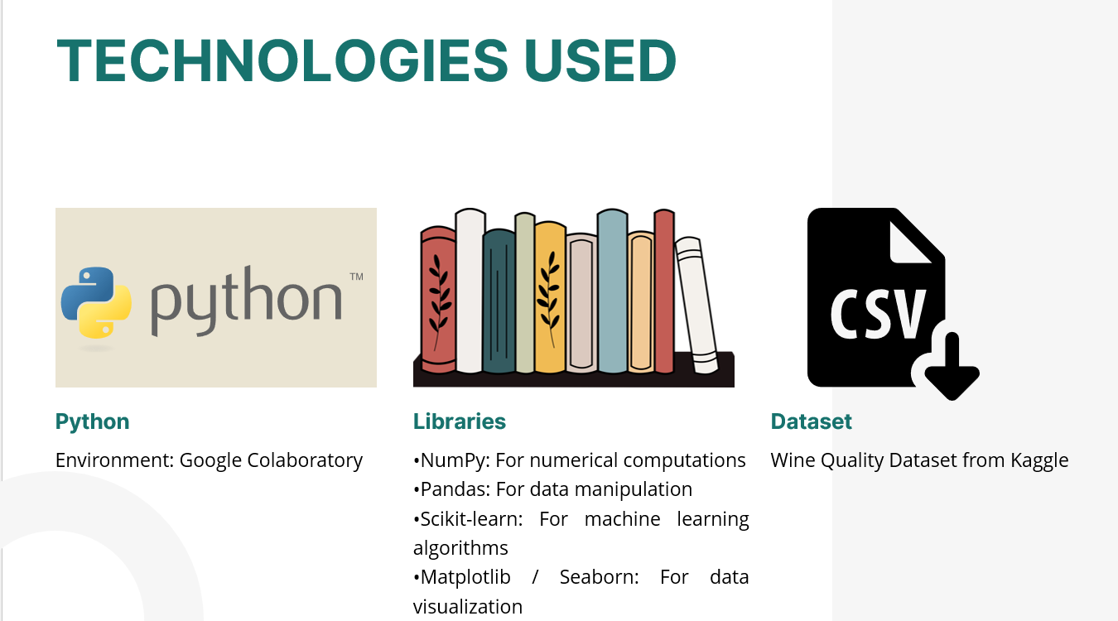

# METHODOLOGIES USED

### WINE QUALITY PREDICTION SYSTEM (ML PROJECT):

Data Preprocessing

1. **Importing the Dataset:**

* + Load the Wine Quality Dataset using Pandas.
  + Inspect the dataset to understand its structure.

2. **Handling Missing Values:**

* + Check for missing values and decide on a strategy:
  + Remove rows with missing values or impute them with the mean/median.

3. **Scaling Features:**

* + Standardize the features to improve model performance.
  + Use Min-Max scaling or Z-score normalization.

4. **Binarizing Wine Quality Scores:**

* + Convert quality scores into binary classes (e.g., quality ≥ 6 is 'good’).

5. **Splitting the Data:**

* + Divide the dataset into training (80%) and testing (20%) sets using train_test_split.

MODEL TRAINING ALGORITHM

* + 1. **Random Forest Classifier:**

Choose the Random Forest algorithm for its effectiveness in handling complex datasets.

* + 1. **Training Process:**
  + Train the model using the training data.
  + Set parameters like the number of trees (e.g., n_estimators=100).
    1. **Testing the Model:**
  + Assess performance with the testing set.
  + Measure accuracy, precision, and recall.
    1. **Random Forest Mechanism:**
  + Ensemble of Decision Trees: Constructs multiple trees from random training data subsets, capturing diverse data aspects.
  + Aggregation for Accuracy: Combines predictions via majority voting to improve accuracy and minimize overfitting, leading to a stronger classification model.

# RESULTS

# 

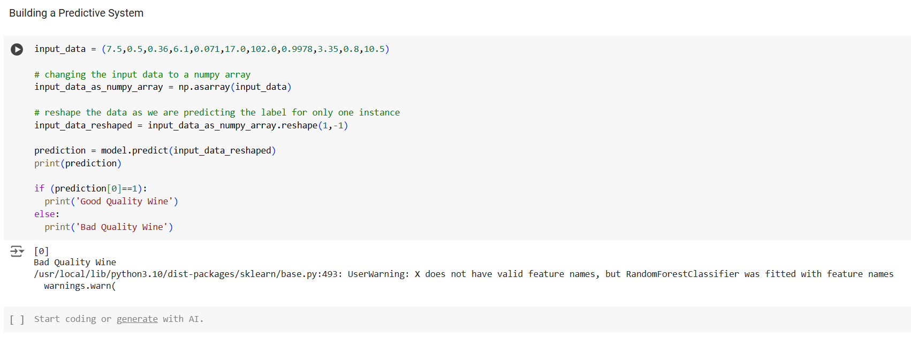

# CONCLUSION

### WINE QUALITY PREDICTION SYSTEM

In the evolving field of wine production and quality assessment, the **Wine Quality Prediction System** stands as a powerful blend of data science and winemaking expertise. This project has successfully culminated in a predictive tool that not only streamlines the process of evaluating wine quality but also enhances accuracy and objectivity, moving beyond the subjective assessments traditionally relied upon.

From the outset, our motivation was clear: to create a reliable, data-driven system capable of providing consistent and accurate wine quality predictions based on chemical attributes. The **Wine Quality Prediction System** has grown into an indispensable tool, enabling winemakers to better understand the factors influencing wine quality and optimize their production processes accordingly.

Throughout the project, we overcame challenges such as data preprocessing, model optimization, and ensuring that the system remained both user-friendly and scalable. By employing robust machine learning algorithms like the **Random Forest Classifier**, we have ensured high predictive accuracy, while the system's ability to provide actionable insights on chemical properties adds immense value to wine producers.

As we conclude the project, we are confident that the **Wine Quality Prediction System** will have a lasting impact on the wine industry. It empowers winemakers with deeper insights, fosters data-driven decision-making, and offers the potential to refine and elevate the art of winemaking for a new era of production excellence.

**REFERENCES**

* + 1. Siddhardhan, "Wine Quality Prediction System" (YouTube Video)
    2. Kaggle, "Wine Quality Dataset”
    3. Scikit-learn documentation for Random Forest Classifier
    4. Google Collaboratory for code execution